

Dr. Pamela, King inc.

2018-11-21

Dr. King

357 Moore Greens, Kurtton, KS 99641

Phone: 5574292278

Fax: 1011989517

**Re:** Sarah, Haynes

**PHN:** 45086425

**Birthdate:** 22-Jul-1936

**Address:** 330 Stephanie Locks, South Jackieview, PA 28778

**Patient number:** 1270503786

To Whom It May Concern:

This is a medical letter to state the above patient is pregnant with expected delivery date of 19-Mar-2025. Hoping this information is satisfactory for your requirements.

Thank you.

Sincerely,

Dr. Pamela, King

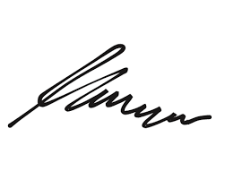

FRCS© NCMP

Clinical Assistant Professor, UBC

Department of Obstetrics and Gynecology SMH